Huawei PCN CloudEngine-20140004 Notice on Changes in TOR Switches' Fan, Power Supply, and Bundle Description - Panel-side Airflow Direction Added
Release History
Version | Change Description | Release Date
Rev: 01 | First version | 2014-10-10

Contents
1. Key Terms 3
2. Abstract 4
3. Vendor 4
4. PCN Information 4
5. Affected Systems and Products 4
5.1 Hardware Change 4
6. Other Changes 5
7. Part Number Change 5
8. Classification 5
9. Change Description 5
9.1 Change of TOR Switch Part Description 5
9.2 Change of Part Labels and Electronic Labels 7
10. Impact 8
11. Affected Documents 8
12. Attachments 8
13. Remarks 9

Key Terms
Term | Definition
PCN | Product Change Notice
Barcode label | Paper stickers attached to the exterior of items to display a code that, when scanned, reveals management information about components.
Item number | ID of an item. Huawei's item number ranges from 8 to 17 digits in length. It consists of letters, numerals, and other characters ("-" and "="). An item number is also known as a part number (PN).
Item revision | One item number may have a number of revisions. An item revision format consists of one letter and two digits.  When an item has internal changes that do not affect its function, only the numerical part of the revision number is upgraded, from A01 to A02, for example. Revision A01 and Revision A02 are interchangeable.  When item functions are changed, only the letter part in the revision number is upgraded, from A02 to B01, for example. Revision B01 can be used to replace revision A02 but the reverse is not true.
Doc version | Version of the drawing used during processing of mechanical parts and cables. After revision management is adopted, the drawing version information is no longer included in the barcode label.
Serial number | Serial number (SN) is the exclusive identifier of an item. The SN can help after-sales personnel identify the maintenance period.
Model | A string of letters and numerals to indicate a specific item.
RoHS | Environment protection information:  Y: The item is RoHS5 compliant. No lead (Pb) information is included.  Y1, Y3: The item is RoHS5 compliant and contains lead.  Y2: The item is RoHS5 compliant and is lead-free.
Country of origin | Country where the item is manufactured
Manufacturer identifier | Manufacturer information that Huawei applies for from the Electronic Data Interchange Forum for Companies with Interests in Computing and Electronics (EDIFICE). The manufacturer identifier of Huawei is LEHWT.
1D code | A 1D code contains the serial number of an item, compliant with ISO/IEC 15417 Code128, and provided for barcode scanning. 1D codes are retained for business continuity.
2D code | A 2D code normally contains the serial number, item number, item revision, and manufacturer identifier information. Some 2D codes do not contain manufacturer identifier information due to length limitations. 2D codes comply with the ISO16022 - Data Matrix standard and are provided for barcode scanning as an upgrade of the 1D code.
FRU | Field replaceable unit
E-label | Readable electronic label provided for active FRUs. An e-label contains the main information in the corresponding barcode label. Due to compatibility with historical revisions, the field names in e-labels may be inconsistent with those in the corresponding barcode labels.

Abstract
The panel-side airflow direction is added to description of fans, power suppliers, and bundles of Huawei data center TOR switches to help customers know the airflow directions and improve user experience.
The change notice is intended for the customers who purchased Huawei TOR switches.

Vendor
Huawei Technologies Co., Ltd.

PCN Information
PCN No. |  | CloudEngine-20140004
PCN Version |  | Rev: 01
PCN Classification |  | D
Milestone | Release Date | 2014-10-10
 | Implementation Date | 2014-10-30
 | EOM Date
 | EOP Date
 | EOS Date

Affected Systems and Products

5.1 Hardware Change
Major System | Product | Hardware | Software | Firmware | Plug-in
TOR series switches | CE5800 | No | No | No | No
 | CE6800 | No | No | No | No
 | CE7800 | No | No | No | No

Other Changes
The sales guide, datasheet, product description, hardware description, configuration manual, and description on UniSTAR SCT are changed

Part Number Change
None.

Classification
The product descriptions, part labels, and electronic labels are modified. This is a type D PCN.

Change Description

9.1 Change of TOR Switch Part Description
The following table describes part descriptions before the change.
Part Number | Model | Description
02359104 | CE5850-EI-B00 | CE5850-EI Bundle0(48-Port GE RJ45,4-Port 10GE SFP+,2-Port 40GE QSFP+,2*150W AC Power Module,2*FAN Box,Front to Back)
02359246 | CE5850-HI-B00 | CE5850-HI Bundle0(48-Port GE RJ45,4-Port 10GE SFP+,2-Port 40GE QSFP+,2*150W AC Power Module,2*FAN Box,Front to Back)
02359081 | CE5810-EI-B00 | CE5810-EI Bundle0(48-Port GE RJ45,4-Port 10GE SFP+,2*150W AC Power Module,2*FAN Box,Front to Back)
02359082 | CE5810-EI-B01 | CE5810-EI Bundle1(24-Port GE RJ45,4-Port 10GE SFP+,2*150W AC Power Module,2*FAN Box,Front to Back)
02359083 | CE6850-EI-B00 | CE6850-EI Bundle0(48-Port 10GE SFP+,4-Port 40GE QSFP+,2*350W AC Power Module,2*FAN Box,Front to Back)
02359084 | CE6850-EI-B01 | CE6850-EI Bundle1(48-Port 10GE RJ45,4-Port 40GE QSFP+,2*600W AC Power Module,2*FAN Box,Front to Back)
02359247 | CE6810-EI-B00 | CE6810-EI Bundle0(48-Port 10GE SFP+,4-Port 40GE QSFP+,2*600W AC Power Module,2*FAN Box,Front to Back)
02359250 | CE7850-EI-B00 | CE7850-EI Bundle0(32-Port 40GE QSFP+,2*600W AC Power Module,2*FAN Box ,Front to Back)
02355422 | FAN-40SA-F | Fan box(SA,Front to Back)
02355423 | FAN-40SA-B | Fan box(SA,Back to Front)
02355421 | FAN-40EA-F | Fan box(EA,Front to Back)
02355338 | FAN-40EA-B | Fan box(EA,Back to Front)
02356153 | FAN-40SB-F | Fan box(SB,Front to Back)
02356152 | FAN-40SB-B | Fan box(SB,Back to Front)
02359096 | FAN-40HA-F | Fan box(HA,Front to Back)
02359097 | FAN-40HA-B | Fan box(HA,Back to Front)
02130970 | PAC-350WA-F | 350W AC Power Module(Front to Back)
02130971 | PAC-350WA-B | 350W AC Power Module(Back to Front)
02310PQP | PDC-350WA-F | 350W DC Power Module(Front to Back)
02310PQN | PDC-350WA-B | 350W DC Power Module(Back to Front)
02310PMJ | PAC-600WA-F | 600W AC Power Module(Front to Back)
02310PMH | PAC-600WA-B | 600W AC Power Module(Back to Front)

The following table describes part descriptions after the change.
Part Number | Model | Description
02359104 | CE5850-EI-B00 | CE5850-48T4S2Q-EI Switch(2*150W AC Power Module,2*FAN Box,Port side exhaust)
02359246 | CE5850-HI-B00 | CE5850-48T4S2Q-HI Switch(2*150W AC Power Module,2*FAN Box,Port side exhaust)
02359081 | CE5810-EI-B00 | CE5810-48T4S-EI Switch(2*150W AC Power Module,2*FAN Box,Port side exhaust)
02359082 | CE5810-EI-B01 | CE5810-24T4S-EI Switch(2*150W AC Power Module,2*FAN Box,Port side exhaust)
02359083 | CE6850-EI-B00 | CE6850-48S4Q-EI Switch(2*350W AC Power Module,2*FAN Box,Port side exhaust)
02359084 | CE6850-EI-B01 | CE6850-48T4Q-EI Switch(2*600W AC Power Module,2*FAN Box,Port side exhaust)
02359247 | CE6810-EI-B00 | CE6810-48S4Q-EI Switch(2*600W AC Power Module,2*FAN Box,Port side exhaust)
02359250 | CE7850-EI-B00 | CE7850-32Q-EI Switch(2*600W AC Power Module,2*FAN Box,Port side exhaust)
02355422 | FAN-40SA-F | Fan box(SA,Front to Back,FAN panel side intake)
02355423 | FAN-40SA-B | Fan box(SA,Back to Front,FAN panel side exhaust)
02355421 | FAN-40EA-F | Fan box(EA,Front to Back,FAN panel side intake)
02355338 | FAN-40EA-B | Fan box(EA,Back to Front,FAN panel side exhaust)
02356153 | FAN-40SB-F | Fan box(SB,Front to Back,FAN panel side intake)
02356152 | FAN-40SB-B | Fan box(SB,Back to Front,FAN panel side exhaust)
02359096 | FAN-40HA-F | Fan box(HA,Front to Back,FAN panel side intake)
02359097 | FAN-40HA-B | Fan box(HA,Back to Front,FAN panel side exhaust)
02130970 | PAC-350WA-F | 350W AC Power Module(Front to Back,Power panel side intake)
02130971 | PAC-350WA-B | 350W AC Power Module(Back to Front,Power panel side exhaust)
02310PQP | PDC-350WA-F | 350W DC Power Module(Front to Back,Power panel side intake)
02310PQN | PDC-350WA-B | 350W DC Power Module(Back to Front,Power panel side exhaust)
02310PMJ | PAC-600WA-F | 600W AC Power Module(Front to Back,Power panel side intake)
02310PMH | PAC-600WA-B | 600W AC Power Module(Back to Front,Power panel side exhaust)

9.2 Change of Part Labels and Electronic Labels
The following figure uses a power supply label change as an example. The description of the power supply marked in the red circle is changed.
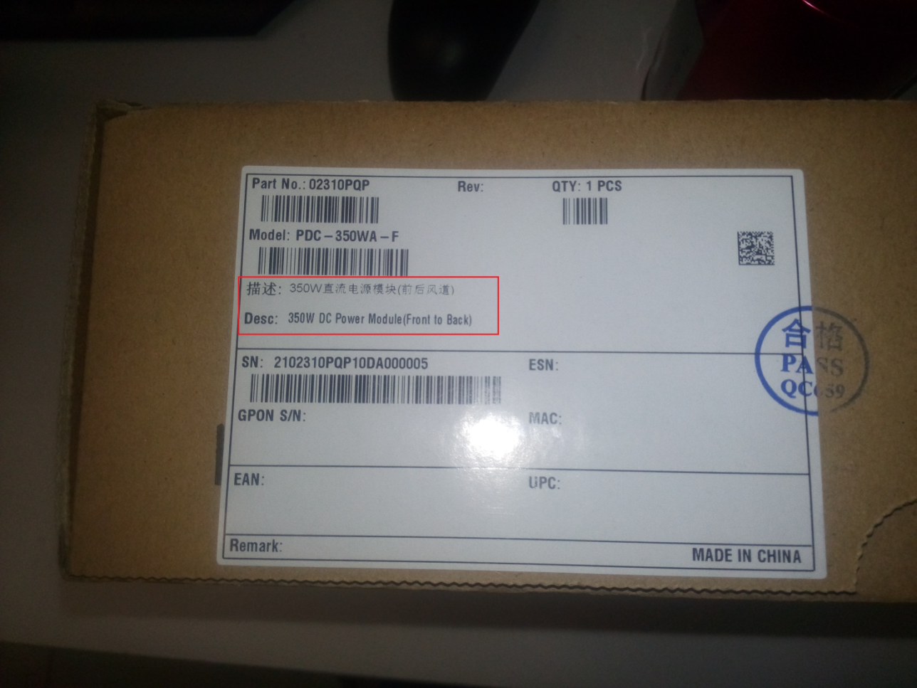

Impact
Safety | Fire | Service | Communication
No | No | No | No
Maintenance | Reliability | Power Supply/Power Consumption | Traffic
No | No | No | No

Affected Documents
The product documentation is updated.

Attachments
None.

Remarks
If you have any question about the change, contact Huawei sales representatives or technical support personnel.

