Huawei PCN CloudEngine-20140005 CE12800 Series Switch CE12812 System Power Switch Change Notice
Release History
Version | Change Description | Release Date
Rev: 01 | First version | 2014-10-20

Contents
Huawei PCN CloudEngine-20140005 CE12800 Series Switch CE12812 System Power Switch Change Notice 1
1. Key Terms 3
2. Abstract 4
3. Vendor 4
4. PCN Information 4
5. Affected Systems and Products 4
5.1 Hardware Change 4
6. Other Changes 5
7. Part Number Change 5
8. Classification 5
9. Change Description 5
9.1 Appearance Change of the CE12812 5
10. Impact 6
11. Affected Documents 6
12. Attachments 6
13. Remarks 7

Key Terms
Term | Definition
PCN | Product Change Notice
Barcode label | Paper stickers attached to the exterior of items to display a code that, when scanned, reveals management information about components.
Item number | ID of an item. Huawei's item number ranges from 8 to 17 digits in length. It consists of letters, numerals, and other characters ("-" and "="). An item number is also known as a part number (PN).
Item revision | One item number may have a number of revisions. An item revision format consists of one letter and two digits.  When an item has internal changes that do not affect its function, only the numerical part of the revision number is upgraded, from A01 to A02, for example. Revision A01 and Revision A02 are interchangeable.  When item functions are changed, only the letter part in the revision number is upgraded, from A02 to B01, for example. Revision B01 can be used to replace revision A02 but the reverse is not true.
Doc version | Version of the drawing used during processing of mechanical parts and cables. After revision management is adopted, the drawing version information is no longer included in the barcode label.
Serial number | Serial number (SN) is the exclusive identifier of an item. The SN can help after-sales personnel identify the maintenance period.
Model | A string of letters and numerals to indicate a specific item.
RoHS | Environment protection information:  Y: The item is RoHS5 compliant. No lead (Pb) information is included.  Y1, Y3: The item is RoHS5 compliant and contains lead.  Y2: The item is RoHS5 compliant and is lead-free.
Country of origin | Country where the item is manufactured
Manufacturer identifier | Manufacturer information that Huawei applies for from the Electronic Data Interchange Forum for Companies with Interests in Computing and Electronics (EDIFICE). The manufacturer identifier of Huawei is LEHWT.
1D code | A 1D code contains the serial number of an item, compliant with ISO/IEC 15417 Code128, and provided for barcode scanning. 1D codes are retained for business continuity.
2D code | A 2D code normally contains the serial number, item number, item revision, and manufacturer identifier information. Some 2D codes do not contain manufacturer identifier information due to length limitations. 2D codes comply with the ISO16022 - Data Matrix standard and are provided for barcode scanning as an upgrade of the 1D code.
FRU | Field replaceable unit
E-label | Readable electronic label provided for active FRUs. An e-label contains the main information in the corresponding barcode label. Due to compatibility with historical revisions, the field names in e-labels may be inconsistent with those in the corresponding barcode labels.

Abstract
Two system power switches are added to Huawei data center CloudEngine 12800 (CE12800) series switch CE12812 to meet customer's power management requirements and improve user experience.
This PCN is intended for the customers who purchased Huawei CE12812 series switches.

Vendor
Huawei Technologies Co., Ltd.

PCN Information
PCN No. |  | CloudEngine-20140005
PCN Version |  | Rev: 01
PCN Classification |  | B
Milestone | Release Date | 2014-10-20
 | Implementation Date | 2015-02
 | EOM Date
 | EOP Date
 | EOS Date

Affected Systems and Products

5.1 Hardware Change
Major System | Product | Hardware | Software | Firmware | Plug-in
CE12800 series switches | CE12812-AC and CE12812-DC | Yes | No | No | No

Other Changes
None.

Part Number Change
None.

Classification
The system power control function is added on the CE12812. This is a type B PCN.

Change Description

9.1 Appearance Change of the CE12812
Before the change:
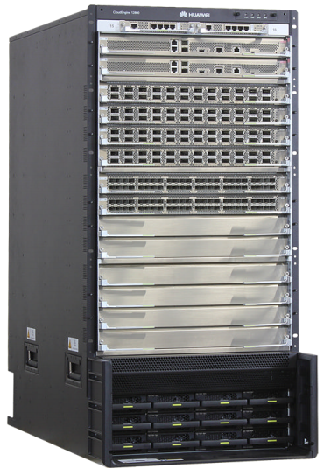

After the change (power switches are marked in a red circle):
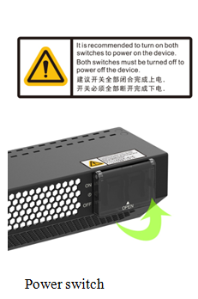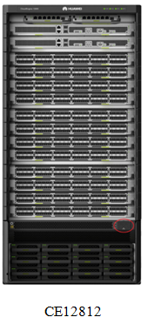

Two power switches are added. The CE12812 is powered off only when the two power switches are turned off. The CE12812 is powered on when only one power switch is turned on. You are advised to turn on both the power switches and close the protection cover.

Impact
Safety | Fire | Service | Communication
No | No | No | No
Maintenance | Reliability | Power Supply/Power Consumption | Traffic
No | No | Yes | No

Affected Documents
The product documentation is updated.

Attachments
None.

Remarks
If you have any question about the change, contact Huawei sales representatives or technical support personnel.

