Huawei PCN AR G3-20140011 AR G3 Enterprise Router AR2220 Fan Change Notice

Release History
Version | Change Description | Release Date

0. Abstract
A fan is removed from the AR2220. This PCN is intended for the customers who purchased Huawei AR2220 series routers.

1. Vendor
Huawei Technologies Co., Ltd.

2. PCN Information
PCN No. |  | AR G3-20140011
PCN Version |  | Rev: 01
PCN Classification |  | B
Milestone | Release Date | 2014-09-30
 | Implementation Date | 2014-09-30

3. Affected Systems and Products

3.1 Hardware Change
Major System | Product | Hardware | Software | Firmware | Plug-in
AR G3 enterprise router | AR2220 | Yes | Yes | No | No

4. Other Changes
Software: The corresponding hosts must run AR V200R005C20SPC500 or later versions

5. Part Number Change
None.

6. Change Reason
A fan is removed to meet product standardization requirements.

7. Change Description
A fan is removed from the AR2220. The old and new AR2220 routers apply to the same operating environment.
The following table lists part numbers of affected products.
Part Number | Description
02352934 | AR2220,3GE WAN(1GE Combo),2 USB,4 SIC,2 WSIC,1 DSP Slot,150W AC Power
02353540 | AR2220,3GE WAN(1GE Combo),2 USB,4 SIC,2 WSIC,1 DSP Slot,150W DC Power
02353558 | BT-NTE-H104 Bundle(Includes AR2220 Base Configuration,8-Port 10/100BASE(RJ45) and 1-Port 10/100/1000BASE(RJ45)-L2/L3 Ethernet Interface Card,3m Shielded Straight Through Ethernet Cable and Britain type Power Cable)
02353978 | AR2220-S,3GE WAN(1GE Combo),2 USB,4 SIC,2 WSIC,1 DSP Slot,150W AC Power
02355088 | AR2220,3GE WAN(1GE Combo),2 USB,4 SIC,2 WSIC,build-in 128-channel DSP,150W AC Power
02359256 | Italy VDF Access Router Bundle1
02358667 | TI POSTE Bundle6 NMU 765469
02350ADP | TI POSTE Bundle10 NMU 767276

8. Impact
Safety | Fire | Service | Communication
No | No | No | No
Maintenance | Reliability | Power Supply/Power Consumption | Traffic
No | No | No | No

9. Affected Documents
None.

10. Attachments
Appearance Change
Before the change:

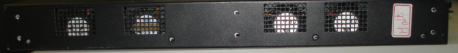

After the change:

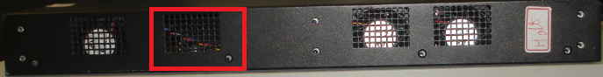

11. Remarks
If you have any question about the change, contact Huawei sales representatives or technical support personnel.

